**Ozan Yarcı – 18.12.2016**

Requirements Document

# 1. User Requirements

1.1 User shall provide profile information, such as:  
• Date of birth  
• Gender  
• Height  
• Weight  
• Notes: Goals, desired weight, nutrition, etc

1.2. User must be able to update weight as they lose or gain weight.

1.3. User shall add information about food consumed.

1.4. User shall add information about energy expended.

1.5. User shall search and find the type of food and enter the quantity so that the application can determine the nutritional value.

1.6. User shall enter information about energy spent by entering information about the type of activity and duration.

1.7. User shall be able to search and browse list of foods that he/she had before and see its details.

# 2. System Requirements

2.1. System shall store weight history according to changes during time.

2.2. The application shall calculate total expenditure according to user information about the type of activity and duration.

2.3. Based on the information provided, the system shall compute information about the user’s energy intake and output as well as the balance (in terms of calories)

2.4. The system shall provide ideal requirements for the given profile in terms of calories, gender, height.

2.5. The system shall show information about the food in terms of its weight and percentage of recommended intake (based on published recommendations.

2.6. The system shall calculate BMI (Body Mass Index) according to  
BMI = Mass(kg) / Height(m) * Height(m)

2.7. The system shall also keep a list of foods that a person had before (My Foods).

2.8. The system shall show the trend of nutritional and energy output for a given interval.

2.9. The system shall be developed using Tomcat/Java

# Mockups

* Login Page

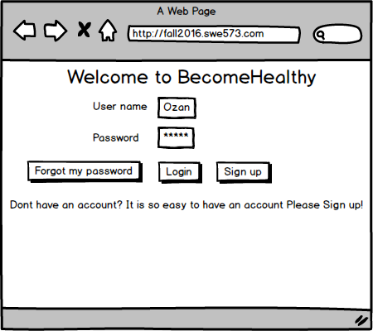

* Sign up Page

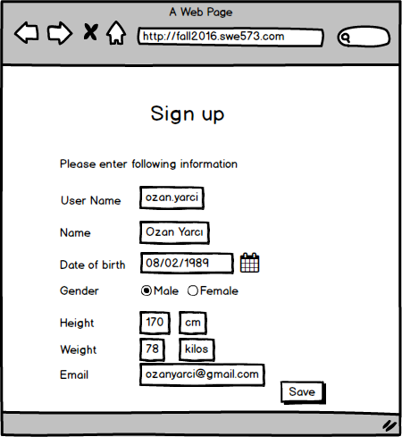

* Recover User Information Page

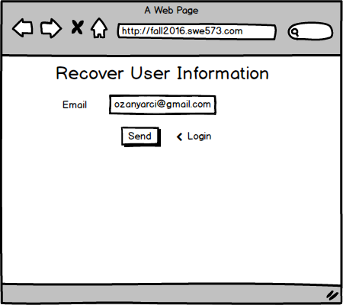

* Home Page

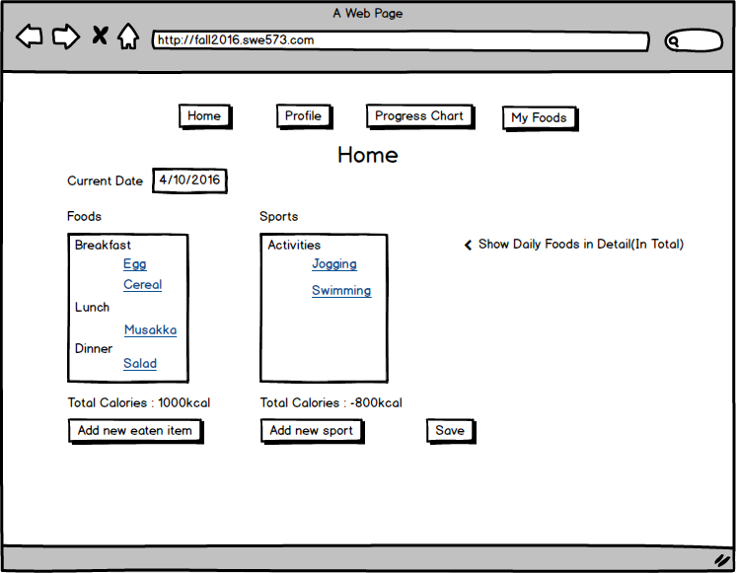

* Profile Page

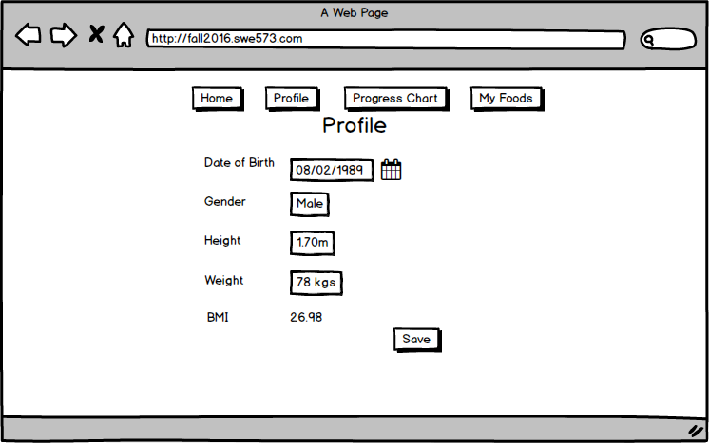

* Progress Chart

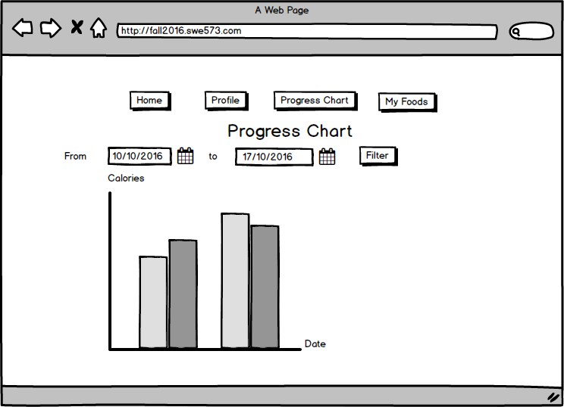

* My Foods

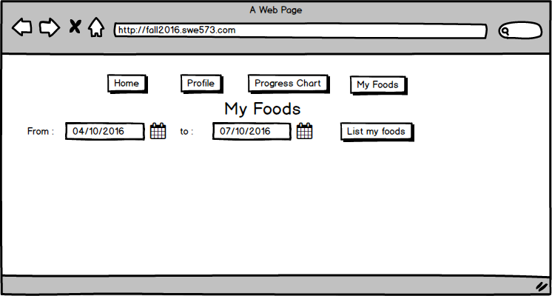

* My Foods Detail

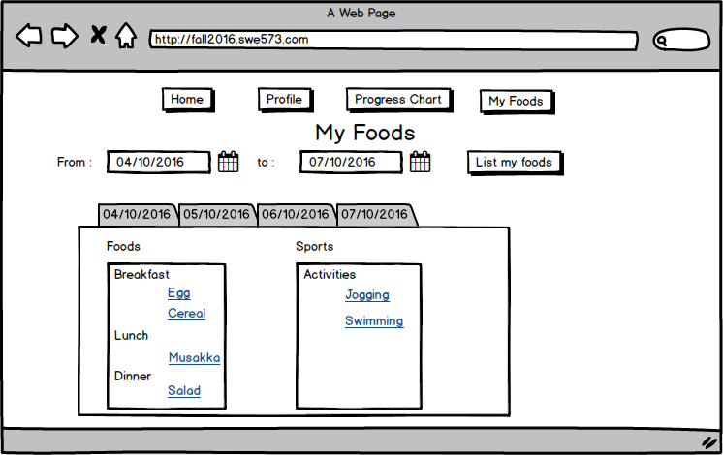

* New Eaten Item

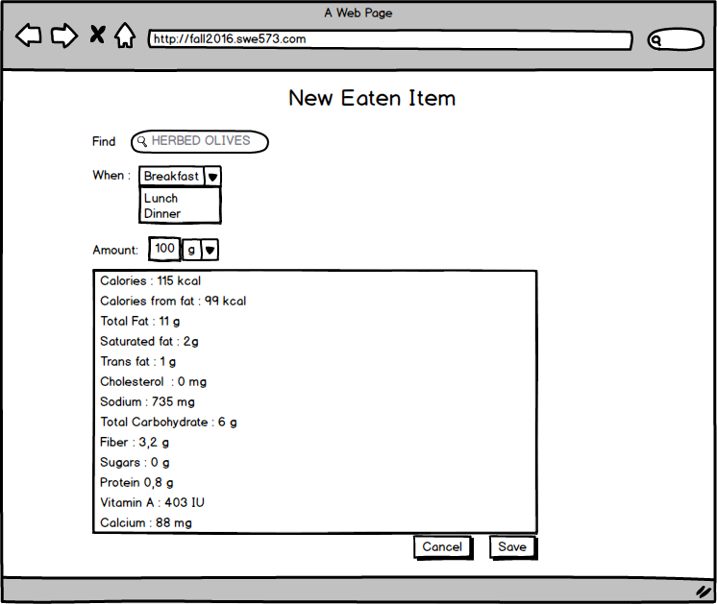

* New Sport

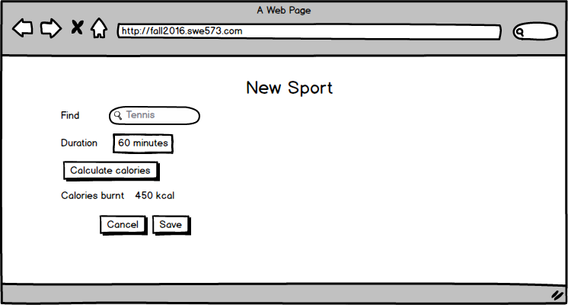

* Daily Summary

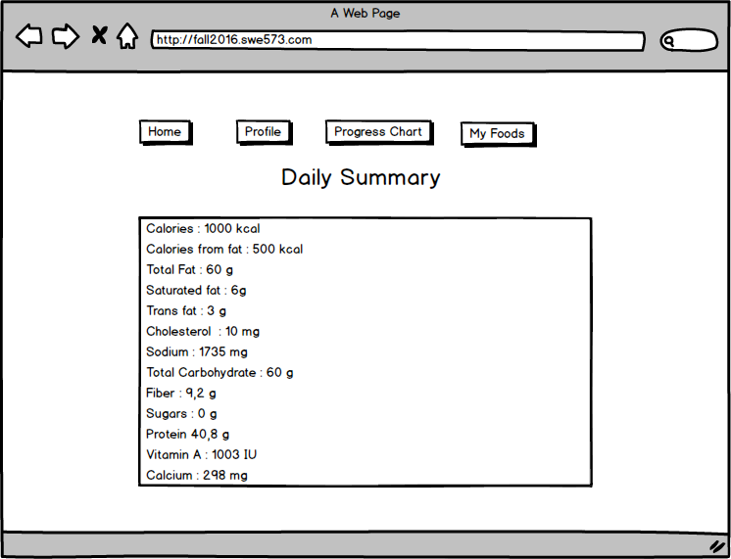

* Egg

